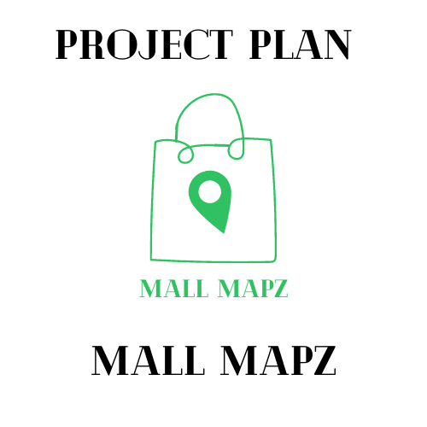





The Cartographers

Lara Leyson, Daniel Pearson, and Romer Rodriguez

May 6, 2022

**I. Introduction (RR):**

The purpose of the following document is to summarize the design requirements for the functions of the app “Mall Mapz”. The following document includes a refined *Class Diagram* including all of design objects, attributes, and methods, as well as pseudocode describing in detail how each class works. The *Statechart Diagrams* will model the lifetime of each object. Finally, the *First Cut Domain Sequence Diagrams* will display the “uses” of each system within “Mall Mapz” in time sequence.

**II. Class Diagram (LL):** Please look at the “Mall Mapz” GitHub Repository

**III. Statechart Diagrams (one per object) (RR):** Please look at the “Mall Mapz” GitHub Repository

**IV. First Cut Domain Sequence Diagrams (one per use case) (DP):** Please look at the “Mall Mapz” GitHub Repository